MCAS Yuma – Job Hazard Analysis
Job / Task: ___________________________________________ 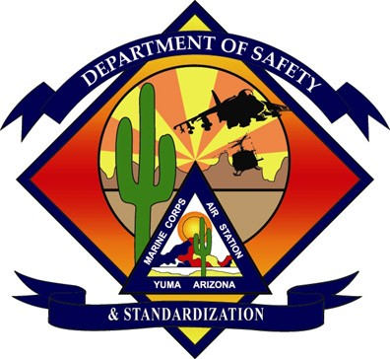

Date | Work Center (Division or branch, etc.) | Building #
Title of Employee Performing Task | Required Personal Protective Equipment to Perform the Task
Completed By (Name) Phone # | Reviewed By (Name & Title) Phone # | Concurrence  Non-Concurrence | No. Of Employees Involved
Sequence of Basic Task Steps | Potential Hazard or Accident | Recommended Action to Prevent  Accident or Eliminate Hazard

