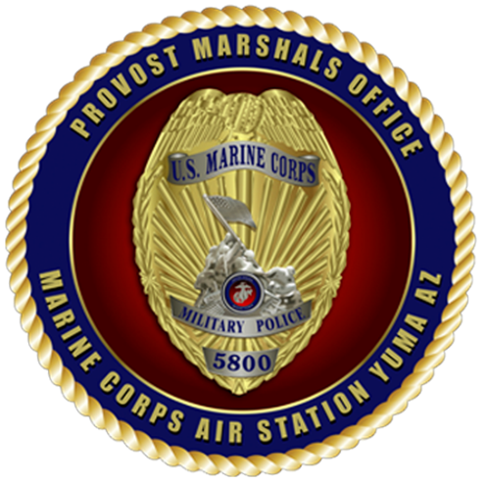

Provost Marshall’s Office Animal Control
1210 Hart Street Yuma Az 85365 / 928-269-6303

- Pet ownership for those service members and their families residing in privatized family housing provides a real and tangible benefit and contributes to Quality of Life for resident families. However, Pet ownership Is a privilege not a right aboard Marine Corps Installations and can be revoked if Residents fail to comply with Station and Marine Corps Orders.

- Upon assignment to housing, all dogs and cats, of any age or status, must be registered within five days at the Provost Marshal’s Office, Building 1210, Department of Animal Control. Call 928-269-6303 to make a registration appointment. Please leave a voicemail if there is no answer. There is a maximum limit of two pets per household, that’s two dogs, two cats, or one of each.

- The following documents are due at PMO Animal Control, BLDG 1210, no later than the due date given at your registration appointment:
- Dogs and cats are required to be microchipped (ISO compatible) and fully vaccinated by 16 Weeks of age. Vaccination requirements will be discussed during the registration process. Unvaccinated pets are NOT permitted in ANY common area.
- The microchip document and Rabies Vaccination Certificate must be delivered to PMO Animal Control no later than your due date.

- Pit Bulls, Rottweilers, canid/wolf hybrids, or any canine breed with dominant traits of aggression present an unreasonable risk to the health and safety of personnel in family housing areas. Effective 11 August 2009 full or mixed breeds of Pit Bulls, Rottweilers and canid/wolf hybrids are prohibited aboard Marine Corps installations. In the absence of formal breed identification, A determination of “majority breed” can be accepted and will be made by a Veterinary Corps Officer (VCO) or a civilian veterinarian at the service member’s expense.

