Request a RFMSS Account
INDIVIDUAL UNIT USER RFMSS ACCOUNTS
PER MARINE CORPS GUIDANCE ON PII ALL RFMSS USERS MUST HAVE INDIVIDUAL ACCOUNTS. USERS MAY NOT SHARE THEIR ACCOUNTS/PASSWORDS WITH ANY OTHER USERS. DOING SO WILL RESULT IN IMMEDIATE SUSPENSION OF THE SHARED ACCOUNT.
https://rfmss.belvoir.army.mil/yuma/pages/login.aspx
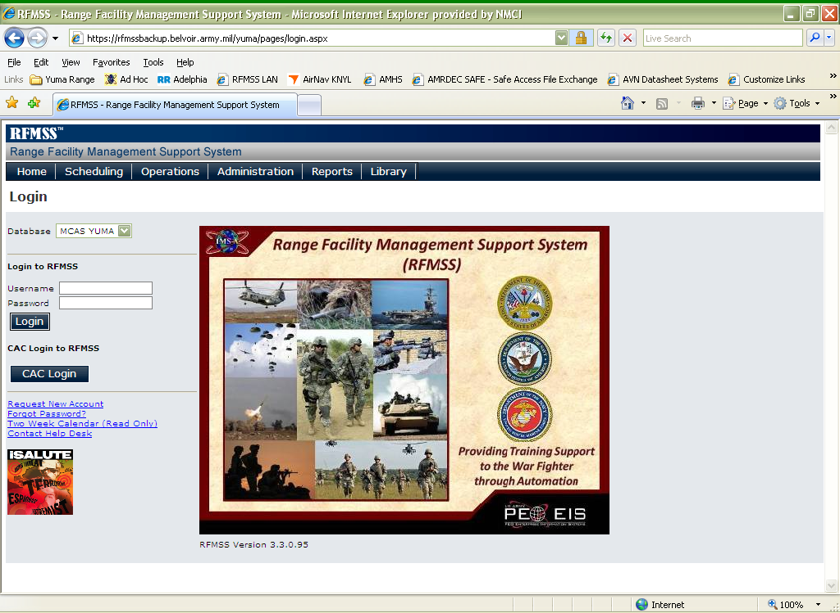
- Click the Request New Account link on the RFMSS Login page. The User page displays the user role grid.
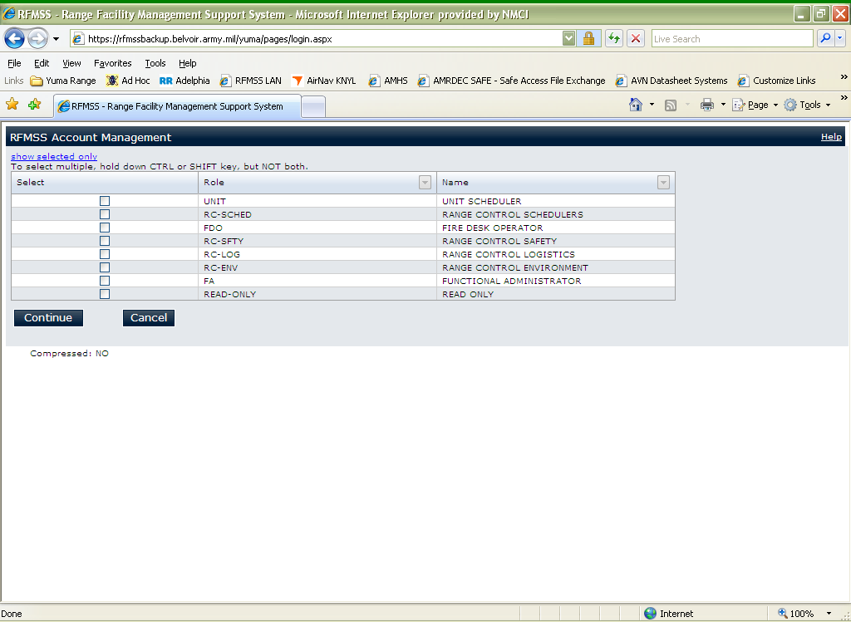
- In the user role grid, select UNIT.

- Click the Continue button. The page refreshes, displaying blank user information fields.
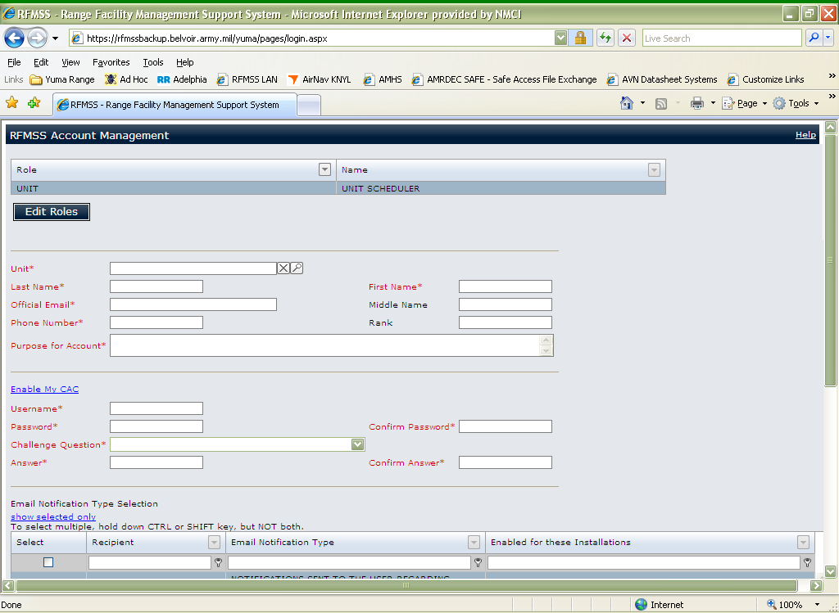
- Enter information in all of the following fields:
- Last Name
Enter your last name (surname).
- First Name
Enter your first name.
- Official Email [required]
Enter your Official (e.g., agency, Government, military, etc.) e-mail address.
- Middle Initial [required]
Enter your middle name
- Phone Number (on the webpage it does not state that this field is mandatory, but Yuma Range is requiring it to approve RFMSS Accounts)
Enter your phone number.
- Rank Code [required]
Enter the abbreviation of your rank (Marine, Navy, Army, Air Force, Coast Guard, Government Civilian (GCIV), Contract Civilian (CCIV), etc. ). Will not be approved without Rank.
- Purpose for Account [required]
Enter a reason that you are requesting an account.
- Username [required]
Enter the user ID that you will use for RFMSS. (Username can be anything with the exception of a unit, example VFA-122 or HMLA-269. These accounts are for individual access, not to be used as a multiple user scheduling account.) Suggest your email account (john.doe1)@usmc.mil . This way you will always remember it.
- Password [required]
Enter a password for your account. Passwords must be at least 15 characters in length and include a combination of 2 upper case letters, 2 lower case letters, 2 numbers, and 2 special characters.
- Confirm Password [required]
Retype your password.
- Challenge Question [required]
Select a new password challenge question.
- Answer [required]
Enter the answer to the new challenge question.
- Confirm Answer [required]
Re-enter the answer to the new challenge question.

5. Click the Save button. The following message is displayed upon successful submittal of the request: "Your account request has been submitted”. You will then need to call Miss Tiffany Rhinehart (RFMSS Functional Administrator) at Yuma Scheduling at 928-269-2215 to validate and activate your RFMSS account.

Note: We cannot see your Password. In the event you forget your password ensure you remember your Challenge Question/Answer to be able to reset your password.
Any changes to an existing account i.e. rank change, unit change, telephone number, or anything that is incorrect within your profile, the user shall contact Miss Tiffany Rhinehart (RFMSS Functional Administrator) to make those corrections.

