COASTAL RIVERINE GROUP ONE (CRG-1)
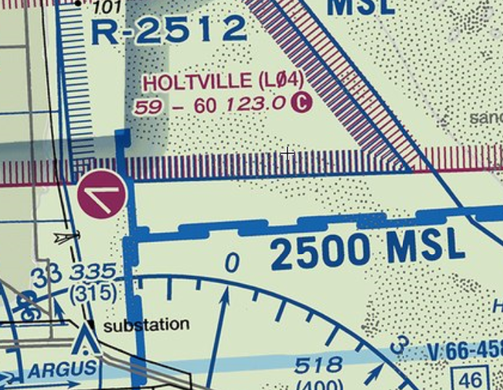
UAS TRAINING AREA
NOTES:
- Deconfliction: Inbound traffic shall stay south of check point “PIG” (Bend in HWY I-8) until situational awareness/communication is established with all users.
- NOTAM: Check “KZLA” NOTAMS for airspace activation dates and times.
PIG
WEST OF YELLOW LINE
( SURF to 1200 ft. AGL )
- N3251.00 W115 14.00
- N3249.00 W115 14.00
Common Freq – 123.0 MHz
PIG – 11SPS619268
RED BOX
( SURF to 2000 ft. AGL )
- N3251.00 W11516.54
- N3249.00 W11516.54
- N3249.00 W11505.30
- N3251.00 W11505.30

