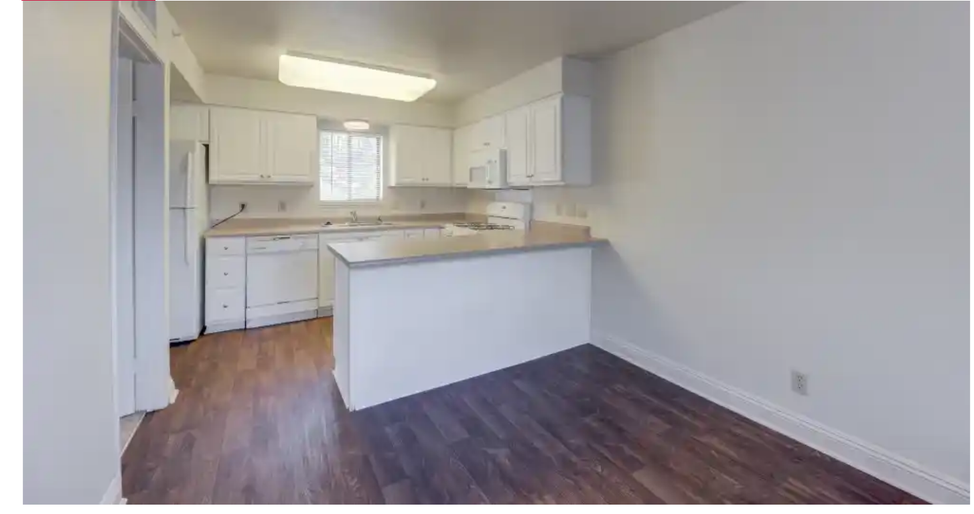

Kitchen and dining room (Fridge, microwave, stove, and dishwasher included in all apartments)

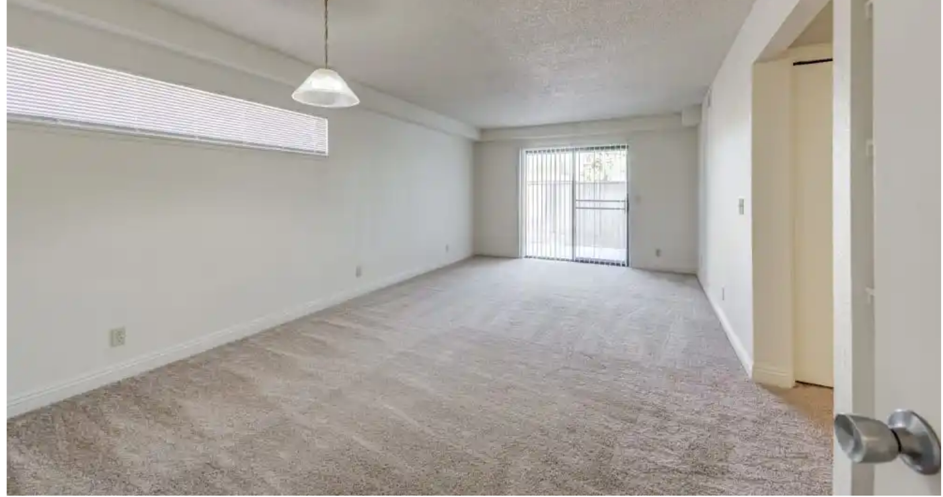

Living room

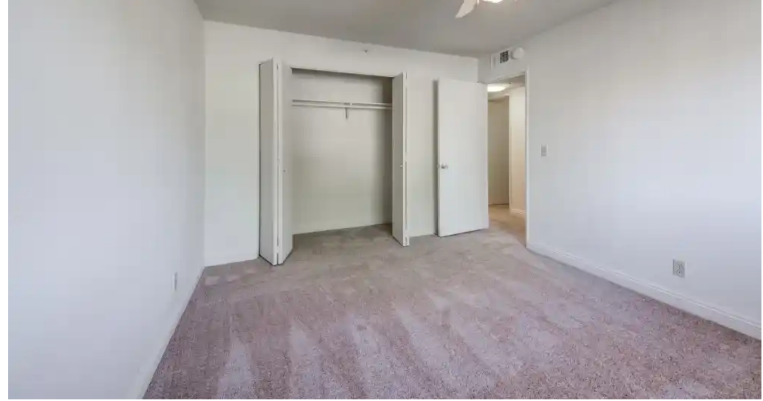

2 bedrooms

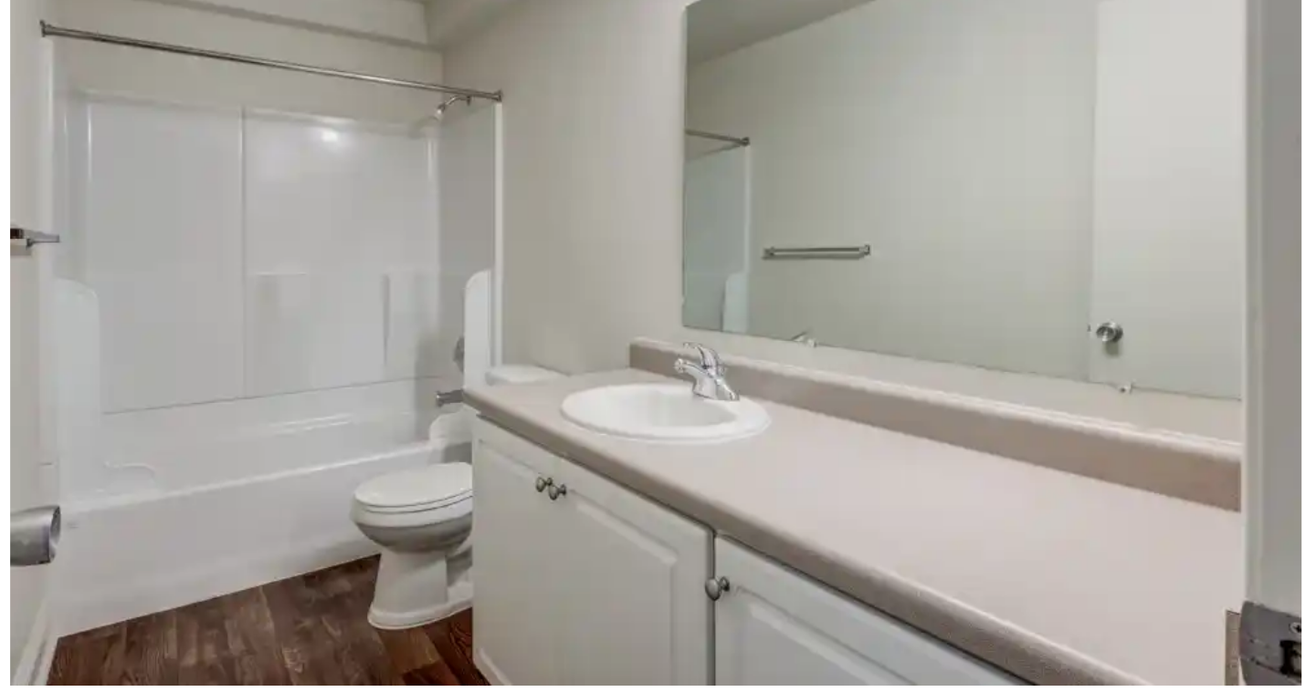

Full bathroom

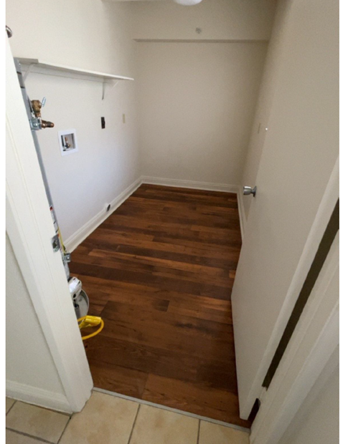

Laundry room hook-ups only (electric)

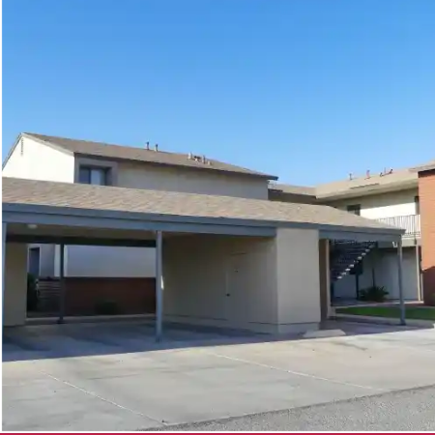

Covered assigned carport (storage room)

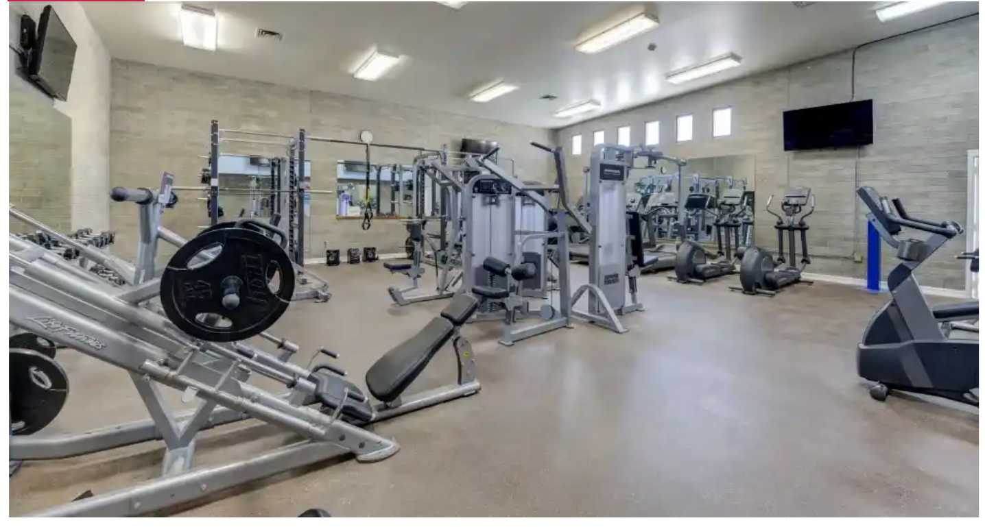

Gym located on site for resident use only. (Key cards will be issued at move in)

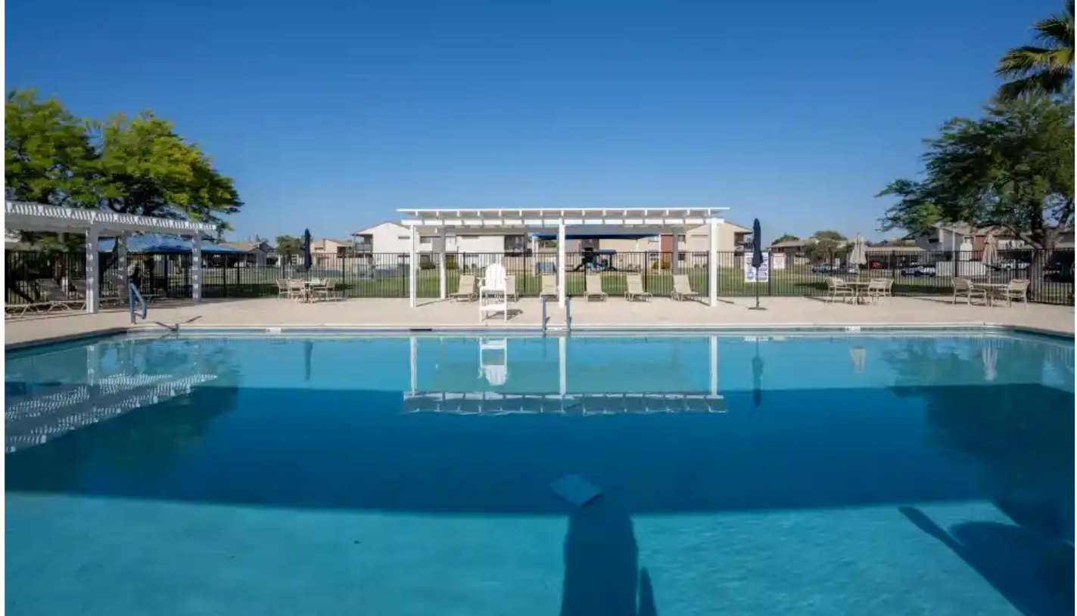

Pool located on property for resident use. (Summer months)

**Flat rent $1000.00 (roommates accepted)**

* No move in deposit required/no allotments walk in rent
* 6 month or 12-month leases
* All utilities included (water, sewer, trash, gas, electricity)

**Additional Features**

* Central air conditioning
* Washer & Dryer connections
* Private Patio or fenced in backyard
* Gas range
* Garbage disposal
* dishwasher
* Microwave

**Community Amenities**

* Swimming Pool with certified lifeguard during operational hours
* Dog park on site
* Basketball Courts on site
* Covered parking
* Fitness Center with free weights
* Little Libraries